**Wribbenhall School**

**Personal, Social and Health Education Policy**

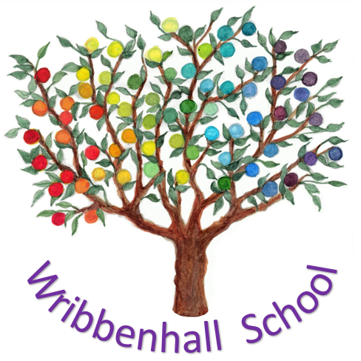

Written: Summer Term 2018

Date of Next review: Autumn Term 2020

**To be read in conjunction with:**

Wribbenhall School Prospectus

Curriculum Policy

**Approved by:**

Proprietor: Ellis Wells

18th August 2018

**Personal, Social and Health Education Policy**

**Introduction**

Wribbenhall School’s PSHE Curriculum includes all aspects of personal, social, health education as well as citizenship. This is provided for all children as part of their regular lessons as well as during group time and SEAL/ circle time and nurture sessions as well as throughout all other aspects of the curriculum. The PSHE curriculum is designed to help to prepare students for life in an ever-changing world. Enabling them to become happy, well balanced young people that can contribute positively to their communities.

**Aims**

The aims of PSHE in key stage 2 are to enable and encourage students to:

* become emotionally literate, confident, motivated learners;
* develop self-care skills, respect for themselves, others and their environment;
* develop their thinking skills enabling them to reflect upon issues and make informed life decisions and solve problems;
* recognise, understand and manage their emotions and thoughts;
* be empathetic towards the feelings of others;
* make links between their and other’s emotions and resultant actions/ behaviours;
* become constructively critical and questioning about current world events.

This programme is based on commitment to equal opportunities for all students and a respect for all cultures and diversity. The programme includes:

Health and personal safety;

* learning about myself and others;
* social awareness and skill development;
* personal relationships and empathy;
* developing learning skills.

Methods of learning are varied, and students are encouraged to express their thoughts and feelings, participate in discussions, literacy tasks, reading and research, reflect and solve problems, paired, group and individual work, outside visitors/ theatre groups, enrichment activities. Topics include:

* self-awareness;
* making friends and healthy relationships;
* physical and emotional health;
* coping with stress and difficult times;
* personal safety;
* community service;
* respect for the local environment;
* respect for others including those with different beliefs, and cultures from our own including people with disabilities;
* bereavement and loss;
* British democracy, fairness, prejudice, crime and the law at Wribbenhall School we have daily timetabled lessons in PSHE/ Seal/ citizenship.

Please see the PSHE curriculum map, available from the school.

The school promotes the development of trusting positive relationships between children and adults in order to support each child pastorally. Staff are experienced as reflective role models and mentors who cultivate the personal and social development of each individual child.

**Protected Characteristics**

The nine protected characteristics:

* age
* disability
* gender reassignment
* marriage and civil partnership
* pregnancy and maternity
* race
* religion or belief
* sex
* sexual orientation

During teaching time and at other times during the school day we are make children aware of the issues surrounding the 9 characteristics and encourage discussion to support their understanding and empathy for each group.

For instance we will discuss the use of disabled parking spaces on an out side trip. Why should we leave that space free? Why do they need that space?